**Real Time Driver Drowsiness Detection**

**Abstract: -** Driver drowsiness is one of the reasons for large number of road accidents these days. With the advancement in Computer Vision technologies, smart/intelligent cameras are developed to identify drowsiness in drivers, thereby alerting drivers which in turn reduce accidents when they are in fatigue. In this work, a new framework is proposed using deep learning to detect driver drowsiness based on Eye state while driving the vehicle. To detect the face and extract the eye region from the face images. A transfer learning strategy is applied to extract effective abstract eye features and improve the classification capability of the proposed model on small sample datasets. The proposed methodology treats drowsiness detection as an object detection task, and from an incoming video stream of a driver, detects and localizes open and closed eyes. MobileNet CNN architecture with Single Shot Multibox Detector (SSD) is used for this task of object detection. A separate algorithm is then used to detect driver drowsiness based on the output from the MobileNet-SSD architecture. To train the MobileNet-SSD Network a custom dataset of about 10000 images was compiled and labeled with the objects face, eye open and eye closed. Out of these,2000 images were randomly separated and used to test the trained model. The proposed methodology, while maintaining reasonable accuracy, is also computationally efficient and cost effective, as it can process an incoming video stream in real time on a standalone mobile device without the need of expensive hardware support.

**Keyword: - i**DrowsinessiDetection, Transfer Learning, MobileNet, Deep Neural Network

**1.Introduction: -**

In a car safety technology, driver drowsiness detection [1-3] is very essential to prevent road accidents. Now-a-days, many people using automobiles for daily commutation, higher living standards, comfortability, and timing constraints to reach destinations. This trend leads to high volumes of traffic in urban areas and highways. In turn, it will raise number of road accidents with several factors. Driver drowsiness could be the one reason for road accidents. One way to reduce number of accidents is early detection of driver drowsiness and alerting with an alarm. To identify the face regions from the input images, various face detection algorithms [6] have been used in the Face Detection phase. For human face detection task is easier, but this task is difficult in computer vision. Face detection techniques are classified into feature-based techniques and image-based techniques. Statistical, Neural Networks and Liner subspace methods have been used by the Image-based approaches for face detection. In the second step, different eye region detection algorithms were used to detect and extract the eye region from the face images. The contrast differences among face images can be adjusted by performing histogram equalization. In the third step, feature extraction was implemented on the input eye region images. There are two main methods for extracting features from images: appearance-based feature extraction and geometric-based extraction methods.

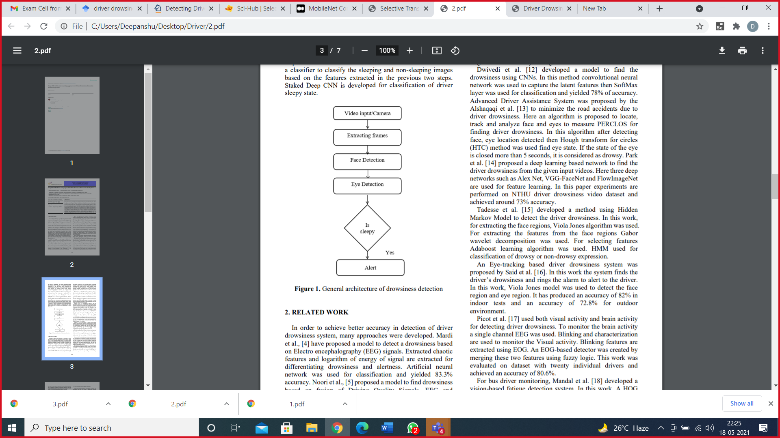

Fig 1: - General architecture of drowsiness detection

There has been a significant rise in the number of vehicles that are equipped with Android Auto or Apple Car nowadays. Most of the cars that are being introduced now have these components built in. Such features are now readily available in lower-end cars too. Due to this, drowsiness detection systems can be easily developed around such built-in Android and iOS platforms. Embedded devices or mobile phones that can easily pair with these car dashboards can be used to enhance driver behavior detection using simple camera setup and state of the art computer vision systems powered by Deep Learning. Microsleeps are of short duration where the driver has his eyes closed and is not perceiving any visual information and thereby cannot react if the car departs from the lane or if the car comes to halt due to harsh braking. With the advent of new sensors and radars in high-end cars, cars can notify or even take action to avoid such crashes. Although this is a great advancement, it would also be beneficial if the car knows that the driver is sleepy and requests him to take rest. Also, another common issue with the current machine vision models is the fact that most of these algorithms are bulky (large in size) and require dedicated hardware to run the models that have been developed. They do not run efficiently on devices with low computational power. This paper details such a Deep Learning-based drowsy detection algorithm that can potentially enable such an intervention, Moreover, it is simple and easy to configure on any mobile or embedded device.

The driver’s physiologic signals during driving are characteristic features that are closely related to recognizing distraction and drowsiness. The driver monitoring system using physiological measurement provides high accuracy and can be implemented in real time [9]. Despite those merits, commercializing the system is difficult because the equipment to collect the data of physiologic signals is usually huge, expensive, and intrusive [10]. There are several wearable devices, such as bands, watches, and headbands, to get physiologic signals, but they are not reliable sources to recognize the driver’s distraction and drowsiness. For these reasons, it is difficult to commercialize the driver monitoring system using physiological measurements.

**2.Related Work**

In order to achieve better accuracy in detection of driver drowsiness system, many approaches were developed. Have proposed a model to detect a drowsiness based on Electro encephalography (EEG) signals. Extracted chaotic features and logarithm of energy of signal are extracted for differentiating drowsiness and alertness. Artificial neural network was used for classification and yielded 83.3% accuracy. Proposed a model to find drowsiness based on fusion of Driving Quality Signals, EEG and Electrooculography. For selecting the best subset of features a class separability feature selection method was used. A self-organized map network was used for classification and achieved 76.51 ± 3.43% of accuracy. Krajewski et al., [9] developed a model to find drowsiness based on steering patterns. In this model, to capture the steering patterns they generated three feature sets by using advanced signal processing methods. Performance is evaluated using five machine learning algorithms like SVM and K-Nearest Neighbor and achieved accuracy of 86% in detecting drowsiness.

An Eye-tracking based driver drowsiness system was proposed by Said et al. [6]. In this work the system finds the driver’s drowsiness and rings the alarm to alert to the driver. In this work, Viola Jones model was used to detect the face region and eye region. It has produced an accuracy of 82% in indoor test.

**3.Experimental Setup**

**Dataset: -**This dataset contains infrared images in low and high resolution, which are captured in various lightning conditions and by different devices. The dataset is suitable for testing several features or trainable classifiers. In order to simplify the comparison of algorithms, the images are divided into several categories, which also makes them suitable for training and testing classifiers. The Dataset contains around 10000 images in which we use 2000 images for training. Also, there is need for categorization for dataset into open and closed eyes in different folders.

**Transfer Learning: -**

Transfer Learning is a well-known Deep Neural Network technique where a pre-trained neural network is used to solve a problem that is similar to the problem the network was initially trained to solve. Transfer learning is a commonly used technique with deep learning as it can overcome many problems associated with deep neural. Using transfer learning can reduce the training time, reduce efforts of tuning many hyperparameters. It is also suitable to be used in case of a relatively small dataset for training to avoid overfitting problems.

**4.Methodology**

The proposed architecture of Drowsiness detection system using Deep CNN is given in Figure 2. The proposed model has three phases 1. Video/webcam,2. Feature extraction,3. Pre-processing 4. CNN MobileNet Classifier Deep Learning model 5. Eye status: - 5.1 open eye 5.2 closed eye.

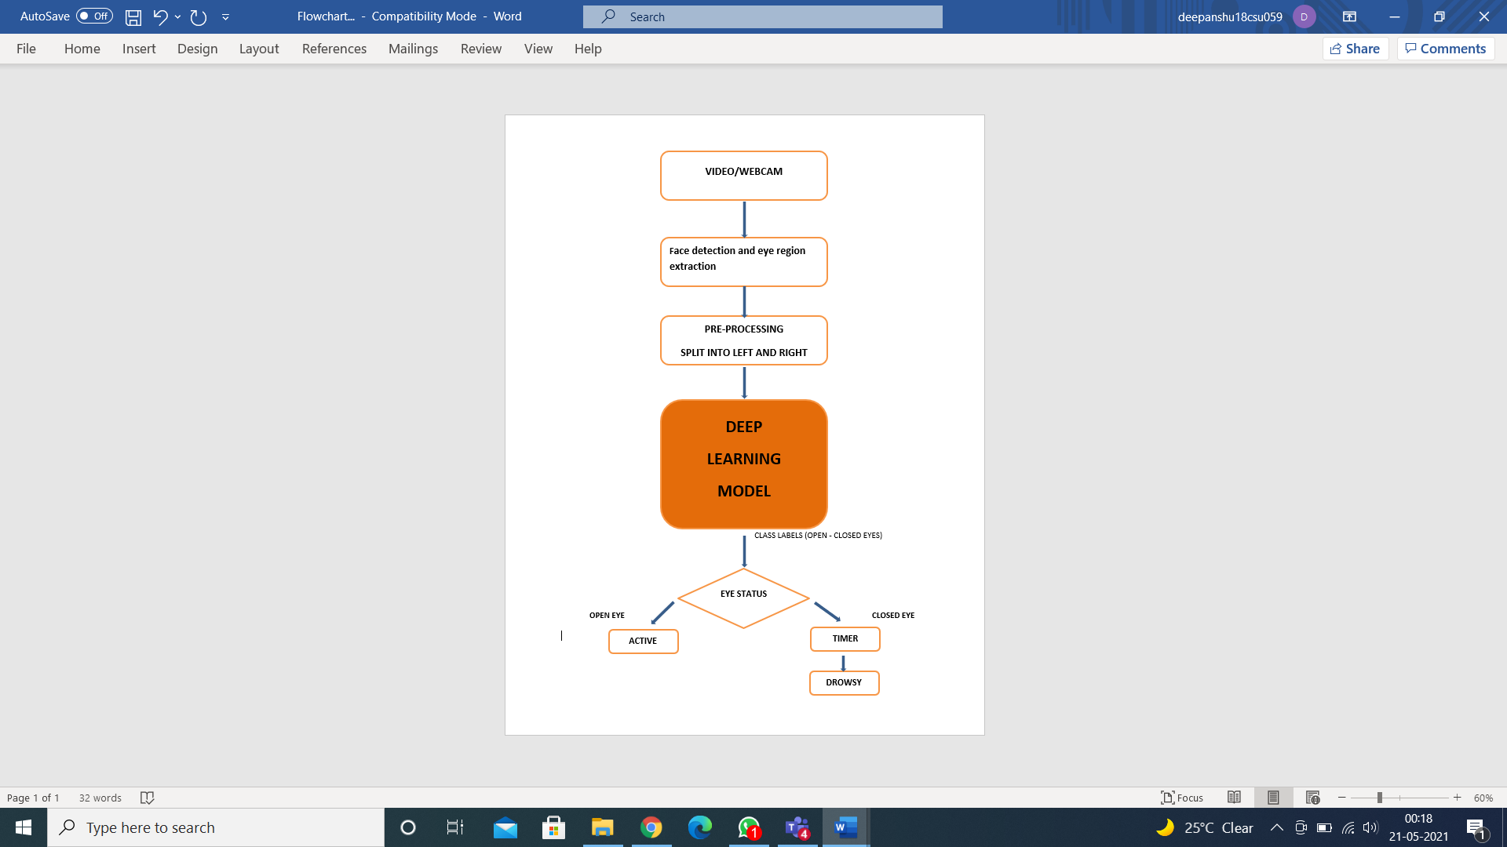

Fig 2 : - Flow chart of methology part of our model

From the flowchart, some steps can be deduced. In the first step, it reads the frame from the webcam, searches for face and detects the eye. Face detection is done by the Viola-Jones face detection method (Viola & Jones 2001; Paul et al. 2018). If it finds the eye then, it will calculate EAR and compare it with a predefined value. In step 3: If the preceding step returns ‘YES, it checks the eye closure time and total blink 4 to5 second. It will alert if any one of the conditions is true. In the final step: When eye closure time does not exceed a predefined value, it returns the process to the initial step.

**5.1 Vedio/webcam**

This process requires a camera to continuously capture the image of the face of the driver. Several portions of the face can be used to detect consciousness level. Analyzing eye blink rate, eye aspect ratio, eye closure time, etc. are some popular methods. This kind of system can warn if the observed result is anomalous to the prescribed value.

**5.2 Face detection and eye region extraction**

Whole face region may not be required to detect the drowsiness but only eyes region is enough for detecting drowsiness. At first step by using the Viola-jones face detection algorithm face is detected from the images. Once the face is detected, Viola-jones eye detection algorithm is used to extract the eye region from the facial images. In 2001, P Viola and M Jones developed the Viola-Jones object detection algorithm [20, 21], it is the first algorithm used for face detection. For the face detection the Viola-Jones algorithm having three techniques those are Haar-like features, Ada boost and Cascade classifier. In this work, Viola-Jones object detection algorithm with Haar cascade classifier was used and implemented using OPEN CV with python. Haar cascade classifier uses Haar features for detecting the face from images**.** Fig- 3 the Eye region images extracted from the face image.



Fig 3: - Eye region images

**5.3 Preprocessing data: -**

During the detection process, the quality of images is affected, and features of the human face become unclear if the illumination intensity within the cab is changed during driving. It is the part of methodology where eyes are split into left and right but make sure that both the eyes are either closed or open. All this done with the help of Haar Cascade Classifier which is just an object detection algorithm which is used to identify the face, left eye or right eye in each image. There are acquisition of 2000 images, 1400 0f these has been used to train and validate (700 with opened eyes and 700 with closed eyes). The rest of 600 images (300 with opened eyes and 300 with closed eyes) are kept for testing.

**5.4 Deep Learning Model (Transfer learning): -**

The use transfer learning with deep learning based on repurposing the pre-trained model for a new problem, similar to that was originally designed for, and it starts with removing the original classifier and adding a new classifier suitable for the new classification target. The change may reach other layers; on the current case, the last fully connected layer also changed. After modifying the model architecture, the model was fine-tuned. Fine-tuning is a common technique for applying transfer learning. Fine-tuning could be performed according to many strategies, in the current work the author selected to re-train the whole model with the new dataset.

The currently popular used techniques for knowledge transfer learning with mobilenet classifier deep learning model could be categorized into two major techniques. These techniques are freezing the convolutional base and fine-tuning based. The first category which is called freeze the convolutional base technique depends on using the pre-trained mobilenet as a feature extractor, where the output of a certain selected layer used to feed a classifier. The second category called fine-tuning usually starts with replacing the classification layer with another one suitable to the new problem and sometimes changing a part of the other layers. Then, re-training mobilenet classifier, by either training the last layer or utilizing deep tuning where all the whole convolutional layers are trained.

The training process required to tune many hyperparameters to reach the desired goal of the model. The model trained with Adam optimizer with initial learning rate of 0.0001, batch size of 32 and gradient decay factor of 0.7.

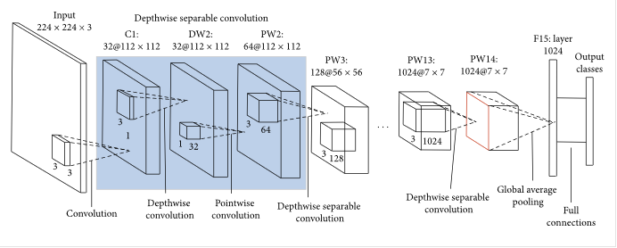

Fig4: - Mobilenet classifier architecture

MobileNets are a family of mobile-first computer vision models for TensorFlow, designed to effectively maximize accuracy while considering the restricted resources for an on device or embedded application [15]. They are small, low latency, low-power models parameterized to meet the resource liabilities for devices. The models can be created for classification, detection, embeddings, and/or segmentation purposes. MobileNets are a class of convolutional neural network designed by Google researchers. As “mobile-first,” they are resource-friendly, and they run immediately on mobile phones. Width multiplier and resolution multiplier are parameters of MobileNets that may be tuned to weigh the resource-accuracy tradeoff. The width multiplied can thin the network while the resolution multiplier can change the input image dimension. These changes can reduce every layer’s internal structure.

**5.5 Eye Status: -**In this eye blinking rate and eye closure duration is measured to detect driver’s drowsiness. Because when driver felt sleepy at that time his/her eye blinking and gaze between eyelids are different from normal situations. By analyzing the driver's eye status, we can determine that driver is drowsy or not and there will two possibilities that is eyes are open or closed. If a driver's eye keeps close for 3 to 4 seconds it is believed that driver is drowsy and not in active state and it will generate an alarm.

**6.Results and Experiments**

For the analysis of the result, this section is divided into two categories (according to the experimental setup). Tiredness detection based on Eye closure time.

Table1: -Summary of experiment

|  |  |
| --- | --- |
| No of epoch | Accuracy |
| 1 | 88.72 |
| 2 | 89.30 |
| 3 | 90.11 |
| 4 | 90.70 |
| 5 | 91.12 |

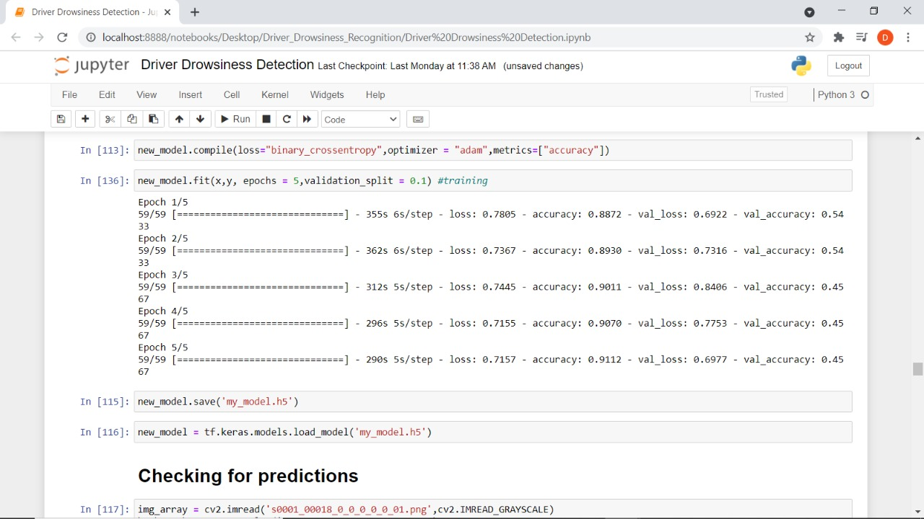

Fig 5: - Evaluation of our model

**Checking for prediction: -**

Case 1:- captured eye images pass to our model checking for prediction If a driver's eye keeps close for 3 to 4 seconds it is believed that driver is drowsy shown by numpy array by negative indexing.

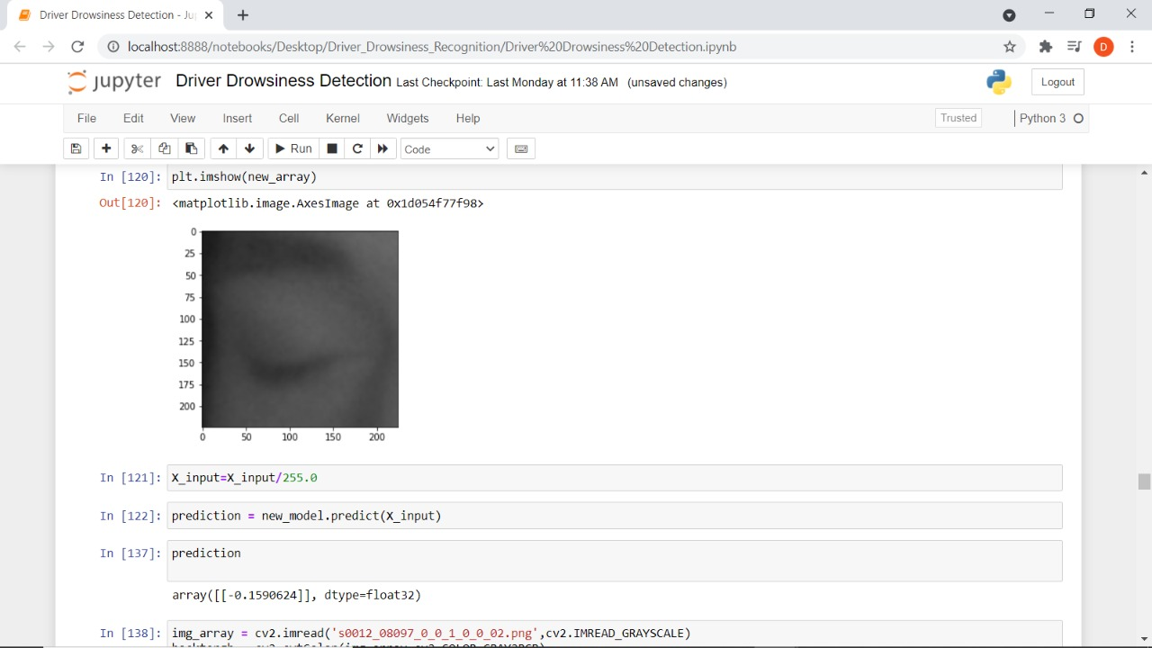

Fig 6: - Evaluate Closed eye

Case 2:- captured eye image pass to our model checking for prediction If a driver’s eye keeps open Or less blinking rate that means driver in active state (not drowsy) shown by postive indexing .

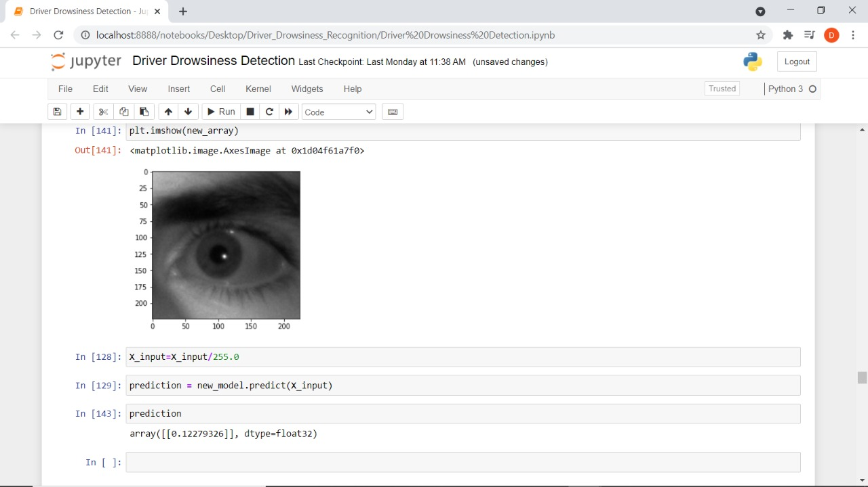

Fig 7: - Evaluate Open eye

Case 3:- Captured Face images pass to our model Firstly Face detection and eye region extractiontechnique apply of our image this extracted eye image check If a driver eye keep open then numpy array pass positive indexing value otherwise driver eye keep closed then numpy array pass negative indexing value.

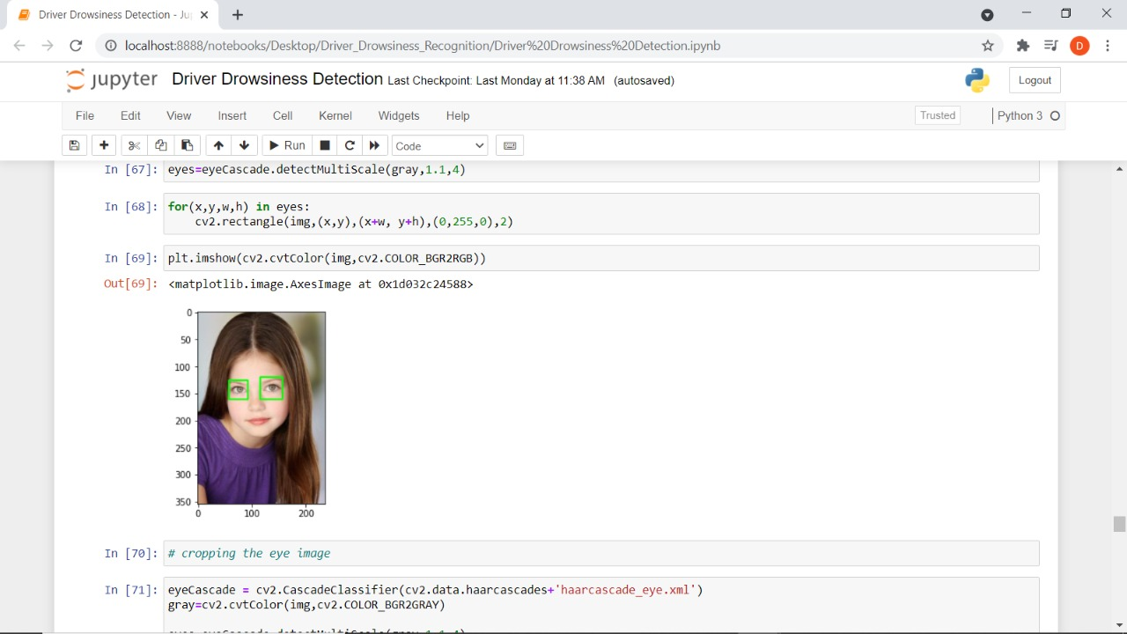

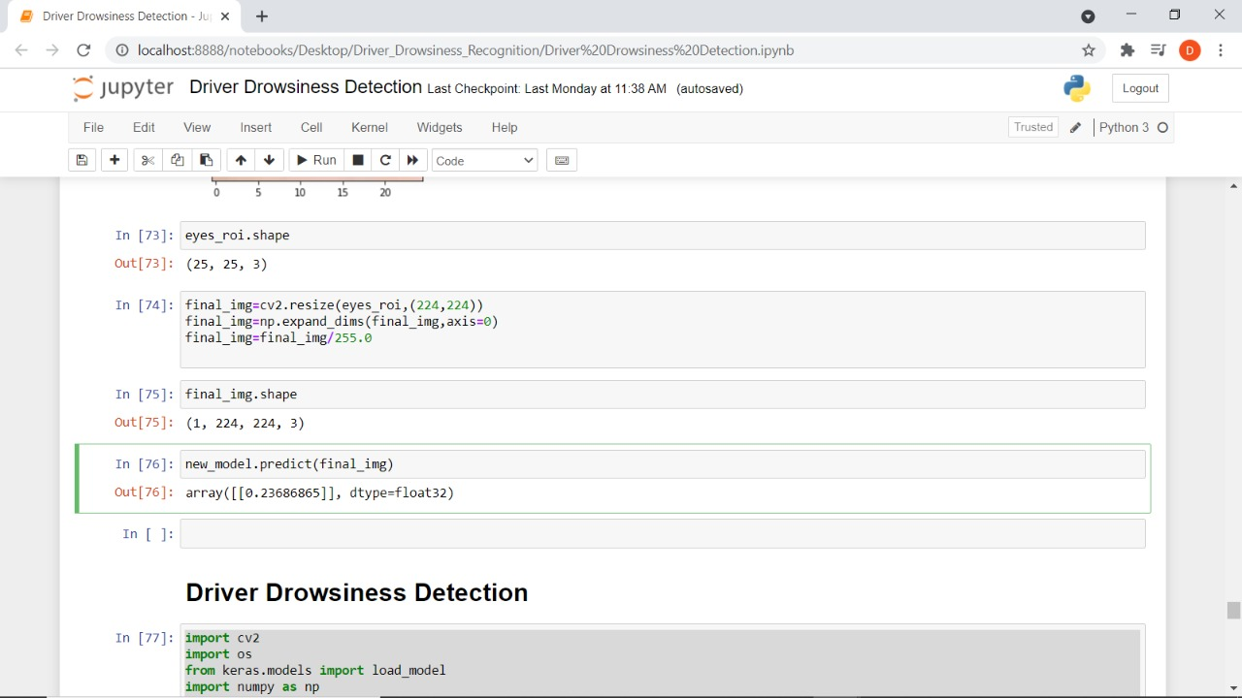

Fig 8: - Evaluate Captured face image.

**7.Conclusion**

A major concern of this paper is to build an automatic system that can detect consciousness of the driver. It can be developed using a simple human-computer interaction using a single camera. In this paper, consciousness has been detected using two different methods, eye closure time and total eye blink greater than 3 second based on the facial landmark. Eye closure time was used to compare with a standard value in normal physical condition. The total eye blink per minute was recorded then compared according to the different time of day. If any of the above methods is unsatisfied then the system decides the driver is unconscious.

In the future, we look forward to integrating this system into an android app to make it easily accessible for all. Then the complexity of implementation will be alleviated, and it will be portable. There will be some complexity in detecting blink at night using android as IR camera is not used. In that situation, a portable IR camera will be added. The improved system will also detect and alert on the situation when a driver uses mobile phones. A lot of drivers use a mobile phone during driving. This is one of the main factors of losing consciousness of drivers. We are planning to make a system to detect if the driver is talking to someone over the phone and coalesce it with the proposed system.

**References**

[1] Vesselenyi Tiberiu, Rus Alexandru, Mitran Tudor, Tataru Bogdan and Moldovan Ovidiu 2016 12th International Congress of Automotive and Transport Engineering (CONAT) (Brasov) VEHICLE DRIVER DROWSINESS MONITORING AND WARNING SYSTEM 873-880

[2] Sullivan T.J., Deiss S.R., Jung T.P. and Cauwenberghs B. 2008 2008 IEEE International Symposium on Circuits and Systems (Washington, US) A Brain-Machine Interface using Dry-Contact, Low-Noise EEG Sensors

[3] Ting Jo-Anne, D’Souza A., Yamamoto K., Yoshioka T., Hoffman Donna, Kakeif S., Sergio L., Kalaska J., Kawato M., Strick P. and Schaal S. 2008 Variational Bayesian least squares: An application to brain–machine interface data Neural Networks 21 1112-1131

[4] Dzitac I., Vesselenyi T. and Tarca R. C. 2011 Identification of ERD using Fuzzy Inference Systems for Brain Computer Interface International Journal of Computers Communications & Control 6 403-417

[5] Cvetkovic D., Übeyli E.D. and Cosic I. 2008 Wavelet transform feature extraction from human PPG, ECG, and EEG signal responses to ELF PEMF exposures: A pilot study Digital Signal Processing 18 861-874

[6] Robert-Nagy Bela, Popentiu-Florin Vladicescu and Tiberiu Vesselenyi 2017 AN ANALYSIS OF ELECTRO-OCULOGRAM SIGNALS PROCESSING USING AN ARTIFICIAL NEURAL NETWORK International Scientific Conference - eLearning and Software for Education

[7 Bengio Y., Lamblin P., Popovici D. and Larochelle H. 2007 Greedy layer-wise training of deep networks Advances in Neural Information Processing Systems

[8] N. Ammour, H. Alhichri, Y. Bazi, B. Benjdira, N. Alajlan, and M. Zuair, “Deep learning approach for car detection in UAV imagery,” Remote Sensing, vol. 9, no. 4, p. 312, 2017.

[9] R. P. Balandong, R. F. Ahmad, M. N. Mohamad Saad, and A. S. Malik, “A review on EEG-based automatic sleepiness detection systems for driver,” Ieee Access, vol. 6, pp. 22908–22919, 2018.

[10] X. Q. Ahmad et al., “Driving fatigue detection with fusion of EEG and forehead EOG,” in Proceedings of the International Joint Conference on Neural Networks, pp. 897–904, Vancouver, Canada, July 2016.

[11] X. Zhao, S. Xu, J. Rong et al., “Discriminating threshold of driving fatigue based on the electroencephalography sample entropy by receiver operating characteristic curve analysis,” Journal of Southwest Jiaotong University, vol. 48, no. 1, pp. 178–183, 2013.

[12] M. V. Ramesh, A. K. Nair, and A. Kunnathu, “Thekkeyil: intelligent steering wheel sensor network for real-time monitoring and detection of driver drowsiness,” International Journal of Computer Science and Security (IJCSS), vol. 1, p. 1, 2011.

[13] C. Anitha, B. S. Venkatesha, and B. S. Adiga, “A two fold expert system for yawning detection,” Procedia Computer Science, vol. 92, pp. 63–71, 2016.

[14] J.-J. Yan, H.-H. Kuo, Y.-F. Lin, and T.-L. Liao, “Real-time driver drowsiness detection system based on PERCLOS and grayscale image processing,” in Proceedings of the 2016 International Symposium on Computer, Consumer and Control (IS3C), pp. 243–246, Xi’an, China, July 2016.

[15] C. Hentschel, T. P. Wiradarma, and H. Sack, “Fine tuning CNNS with scarce training data-adapting imagenet to art epoch classification,” in Proceedings of the IEEE International Conference on Image Processing (ICIP), Phoenix, AZ, USA, September 2016.

[16] A. El-Fakdi and M. Carreras, “Two-step gradient-based reinforcement learning for underwater robotics behavior learning,” Robotics and Autonomous Systems, vol. 61, no. 3, pp. 271–282, 2013.

[17] Z. Zhao, C. Ye, Y. Hu, C. Li, and L. Xiaofeng, “Cascade and fusion of multitask convolutional neural networks for detection of thyroid nodules in contrast-enhanced CT,” Computational Intelligence and Neuroscience, vol. 2019, Article ID 7401235, 13 pages, 2019.